Creative Victoria
Live Music Venues Program

Online Acquittal Guidance

Introduction
If you receive a grant from Creative Victoria, at the conclusion of your funded activity you will need to complete an acquittal report – including financial reconciliation – that evaluates the project and accounts for how the funds have been spent.
Acquittals are completed via the online Creative Victoria Grants Portal at http://grants.creative.vic.gov.au.

Why you need to acquit your grant
Having completed your funded project, Creative Victoria needs to gather information from you.
The information you provide in your online Acquittal Report will:
- account for your use of public funds, demonstrating that the funding was used for the purpose for which it was provided and in accordance with your funding agreement
- assist Creative Victoria in assessing how successful funding programs are in meeting the needs of the arts sector and the Victorian community
- provide you with the opportunity to make suggestions regarding improvements to the funding program

When should you acquit your grant?
Your Acquittal Report due date and full acquittal requirements are specified in your funding agreement and at www.creative.vic.gov.au/acquittal.

The acquittal form questions will be available online as soon as your grant is confirmed, but you won't be able to submit them until your project finishes.
You can start filling in the acquittal information as soon as you have it – this is particularly useful for grants that comprise multiple performances, exhibitions or workshops.

If you have any difficulty providing your report on time or complying with any specified requirements, you should discuss this with your contact at Creative Victoria as soon as possible.

What happens if you don’t acquit?
If you do not satisfactorily acquit your grant you will not be eligible to apply for further Creative Victoria funding and action may be taken to recover the grant.

Acceptance of your acquittal
We will notify you once we have received and accepted your Acquittal Report. You will then have completed all of your obligations under the funding agreement.

Auspiced grants
As with the application process, if the grant is being auspiced both the auspicing body and the individual artist may complete the forms but the acquittal can only be submitted by the auspicing body.

How to submit an online acquittal

Getting started
Acquittals are submitted online using the Creative Victoria Grants Portal. You'll need to log into the Grants Portal using the email address you registered with: this will be the same email address that the acquittal reminder email sent to.
You can find the link the Acquittal Report forms in the MY GRANTS section of the Grants Portal.
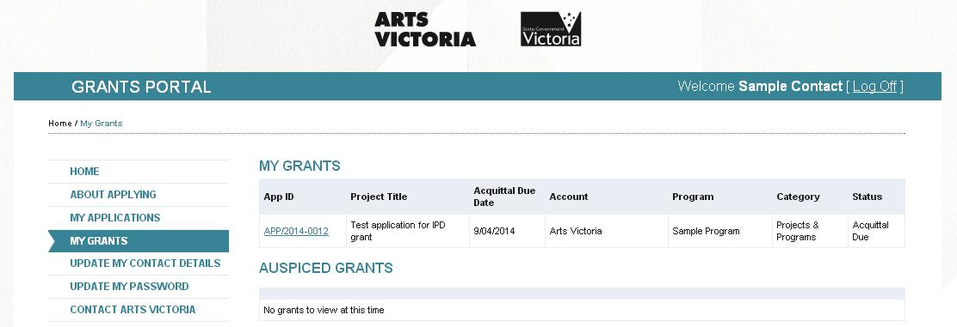
After clicking into the grant and selecting Acquittal, you will be taken to the acquittal Summary Screen where you will see there are eight short sections to complete in a standard acquittal, plus the opportunity to submit acquittal support material.

Do you have to answer every question?
While the form itself requires most questions have an answer entered, some questions may not be relevant to your project. In these cases, please answer N/A (not applicable), 0 (zero, for answers that require a number) or, in cases where you are unable to provide the information, please answer DK (don’t know).
The Check Acquittal on button at the bottom of the summary screen will let you know if you've missed any questions.

Section 1 – General Section
This allows you to revise the original project title and dates.
You only need to enter a new project title if it's changed, but conformation of the project start and end dates is mandatory.

Section 2 – Project Evaluation
The three questions in this section allow you to reflect on your project in qualitative terms. They are:
- Describe the funded activity, including any changes to the project that was outlined in your original application.
- Provide an assessment of the impact of your project (with particular reference to the objectives stated in your application) and include any unexpected outcomes.
- In evaluating your project, is there anything you would do differently? If so, please describe.
Try to be as objective as you can as this evaluation contributes to the continual improvement of program management.

Section 3 – Activity and Attendance
To help us monitor Creative Victoria's geographic distribution of funds we collect the location(s) of where funded activities take place, and the type of attendances (ticketed vs non-ticketed, and paid vs unpaid).
Your project might have involved one or many activities. Enter a separate activity by clicking the “Add an Activity” button.
If your activity involved touring an activity, please enter a separate activity record for each suburb visited. Similarly, if you completed different activities in one place, enter separate records.
If your project involved essentially one activity that ran over a number of days or nights, just enter one record and enter the commencement date as the Activity Date. Use the Number of Activities field to show how many performances, days or sessions it had.
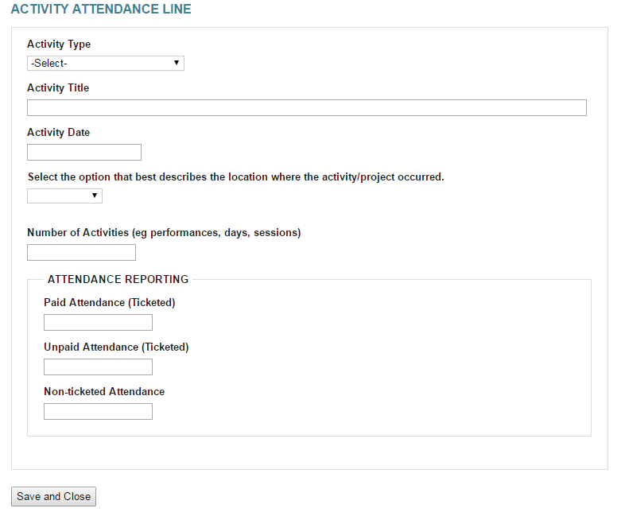

Section 4 – Activity Targets
This is where you record how many specific community participants – ie, those who are not professional artists – were involved in the funded project.
Specific communities include:
- Children (up to 12 years old)
- Youth (12 to 25 years old)
- Women
- Aboriginal / Torres Strait Islander people
- People from culturally and linguistically diverse backgrounds
- People with disabilities
- Senior citizens.
- LGBTI

Section 5 – Employment
Include figures relating to the employment of artists, volunteers and others that resulted from the Creative Victoria funding.
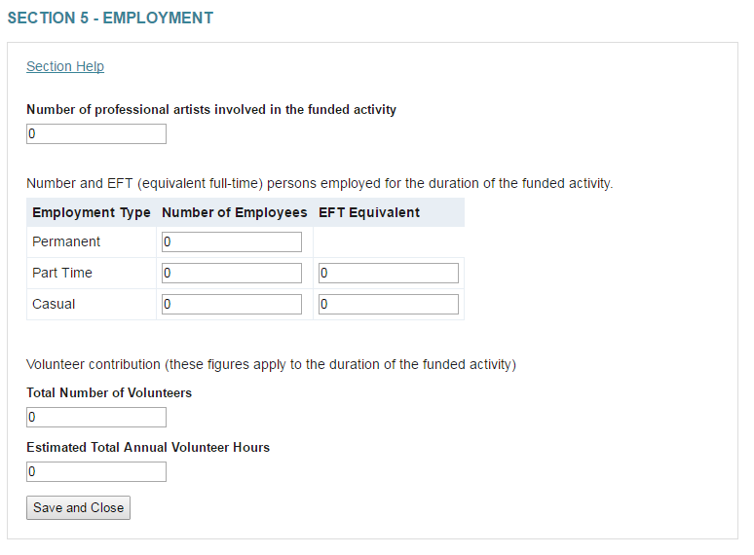

Section 6 – Project Measures
We collect this information to report on funding programs and their reach. If a question is not relevant to you, enter zero.
Measures include:
- Live music gigs/events
- Musicians/artists involved
- Future live music gigs/events programming
- Non-creative workers involves

Section 7 – Financial Reconciliation
You must complete the financial reconciliation section by indicating how you utilised the funding and by providing a final budget detailing the actual expenditure of the grant.

Financial reconciliation explained
All recipients are required to submit a final budget covering the funded period and detailing how the funding amount was spent. You must include your final budget as an attachment to fulfil this requirement. You can include both your final and application budgets in one document for comparative purposes if preferred.

Independent audit condition
If your funding level is over a certain amount, you must include an opinion or certification by an independent auditor to verify that your financial reconciliation is a true and fair view of the income and expenditure of the project.
This requirement will be listed in the Deliverables Table in your Common Funding Agreement.
You will need to either upload a scan of the opinion or certification signed by an independent auditor with your Acquittal Report in the Acquittal. An independent auditor is a member of the Institute of Chartered Accountants, CPA Australia or the National Institute of Accountants, who is not employed by or related to the funding recipient.

Section 8 – Program Evaluation
The feedback about the funding program and processes contributes to the continual improvement of program management.
Please try to answer the question, but if you have no comments type 'N/A'.

Acquittal Documents and Supporting Material
You may accompany your Acquittal Report with supporting material to:
- provide us with further details about the outcomes of your project
- illustrate the listing of your project that is published on our website
- have your project included in Creative Victoria presentations and publications.
You can upload and submit up to ten files and/or ten URLs (external links) of relevant support material. Wherever possible, please use URLs and link to existing online material rather than uploading files. A final budget and an opinion/certification by an independent auditor must be attached to your acquittal.
Add brief notes to explain the context of the file or URL. If the URL is password protected, remember to provide the password here.

Files/URLS

Files
Any file you upload can be no more than 25MB in size.
The following programs and file extensions are accepted as attachments:
File Type File Extensions
MS Word .doc .docx
MS Excel .xls .xlsx
MS PowerPoint .ppt .pptx
Adobe Acrobat .pdf
Image .jpg .png .tiff
Audio .mp3 .wma
Video .mp4 .wma .avi .mov

URLs
Enter the URL in the field provided. You can copy and paste a URL or type directly into the field. You can include the "http://" at the start of the URL but it is not required.
If URLs are not publically available please include login/password details.

Types of supporting material

Images
Creative Victoria is always seeking dynamic images of arts activities, projects and events to enliven our website, promote funded activities and to accompany media releases, presentations and publications.
The ideal image resolution is 300 dpi (print quality), with a size of 500kb-1000kb (1MB) per picture. Images should be in JPEG or PNG format. If the ideal resolution can’t be met, JPEG files at lower resolutions are acceptable.
Creative Victoria website, publications and presentations – Image rights
If you would like to allow Creative Victoria to publish your images you need to provide us with relevant captions and photographer credits in the Title and Notes fields of the File Details of your upload, or submitted separate upload.
By submitting images for publication you confirm that, per the Intellectual Property clause in your funding agreement, you have the rights that allow us to publish them.

Music
Digital audio files should be in MP3 or WMA, compressed to a minimum of 192 kbps.

Video
Videos can be of multimedia presentations, live performances, rehearsals or any other activities related to your project.
Due to 25MB per file limit, it is preferable that you submit URL links to existing video footage rather than uploading individual video files.

Submitting your acquittal
Click on the Check Acquittal button to make sure you have answered all the mandatory questions. If there are any issues a red message will appear at the top of the page.
Once all questions have been answered, you can click on the Submit Acquittal button. A pop-up will ask you for confirmation. You will not be able to make changes to your acquittal once you submit.

Frequently Asked Questions
What do I do about expenditure that wasn’t on the original budget?
Changes to the allocation of funding are ok, so long as the funding is still only spent on eligible costs as outlined in the program’s Guidelines. You can make a note of any major changes to the actual expenditure of the grant in the final budget you submit with your acquittal.
What is the financial verification / independent audit, and when is it required?
An independent audit is a certification provided by an independent auditor that verifies that the final budget you provide for the grant expenditure is a true and fair view of the income and expenditure of the project.
It is required for all grants over $40,000. Please check your Common Funding Agreement to see if you are required to provide an audit report.
How do I get an auditor?
An independent auditor is a member of the Institute of Chartered Accountants, CPA Australia or the National Institute of Accountants, who is not employed by or related to the funding recipient. You will need to source your own auditor.
Do I need to acquit the amount received, or the amount received+GST?
You should only acquit based on grant amount you received, not on the GST included with your payment.
I’ve forgotten my log in password for the Grants Portal – what should I do?
You are able to reset your password here. Make sure you are using the email you used to apply for the grant. If you are still having difficulty, please contact your Creative Victoria Program Officer.
I don’t think I can complete my acquittal on time – can I get an extension?
If you are having trouble completing your acquittal or do not think you can submit by the due date, please request an extension in writing by emailing your Creative Victoria Program Officer.

If you need help completing your acquittal, contact your Creative Victoria Program Officer or contact Creative Victoria reception on 03 8683 3100.

