Creative Learning Partnerships
Documentation Specifications for Acquittal

Photographic Documentation

Please upload to Acquittal Portal:
- Up to 10 high quality image files
- That look clear, sharp and bright
- With good composition
- Featuring no more than three (3) people
- That are 300 dpi (print quality), with a size of 500kb -1000kb (.jpg or .png. or .tiff files*)

That also illustrates:
- The art-form of the project
- The type of project
- The artist working with the student AND/OR
- The work in progress AND/OR
- The final outcomes including audience participation AND/OR
- The teacher working with the artist AND/OR
- Other peer learning

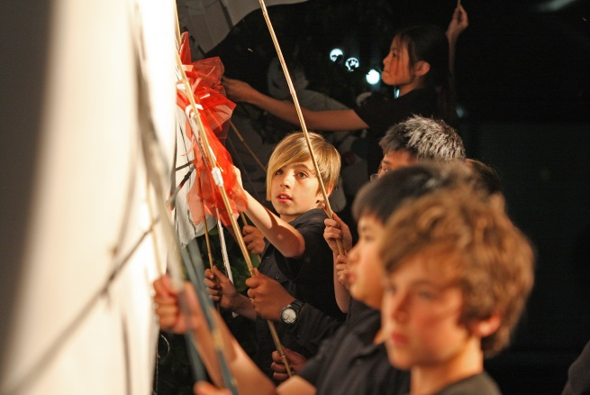

Image from Footscray Primary School with Jo Trevathan. Photo by Dan O’Brien.

Please note:
- When uploading the caption, credit information for each image in the field provided

*(If the specifications can’t be met, JPEG’s at lower resolutions are acceptable.)

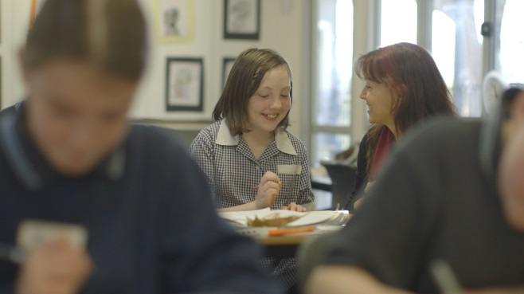
Image from Seville Primary School with Lia Hills. Photo by Singing Bowl Media.
Video Documentation

Consider, before filming, how the vision and audio will be captured to ensure best production values, e.g. use of a tripod, best position regarding light and sound sources. Will you need an extra mic to pick up the audio?

Please upload to Acquittal Portal:
- Videos of performances or digital art works such as animation and web pages
- Due to 25MB per file limit, please submit URL links to existing video footage AND/OR
- Selected stills from the DVD for publication
- Preferred Resolution – 640 x 360 px (widescreen) minimum 400 x 300 px, 25 frames per second (fps)

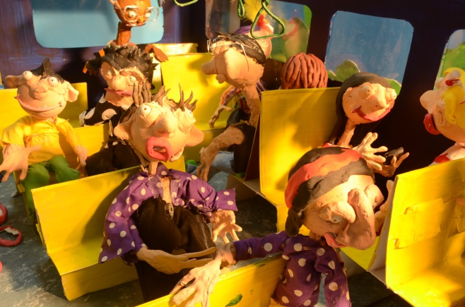

Image from Montague Continuing Education Centre with Dave Jones

Audio Documentation

Please upload to Acquittal Portal:
- Audio of music/sound performances and/or compositions
- Digital audio files should be in MP3 or WMA
- Compressed to a minimum of 192kbps

Curriculum Materials

Please email copies of
- Relevant curriculum plans AND/OR
- Relevant assessment rubrics AND/OR
- Unit of work planners AND/OR
- Lesson plans AND/OR
- Sketches, drafts, designs AND/OR
- Screen shots of web-based resources AND/OR
- Relevant school newsletters and media

